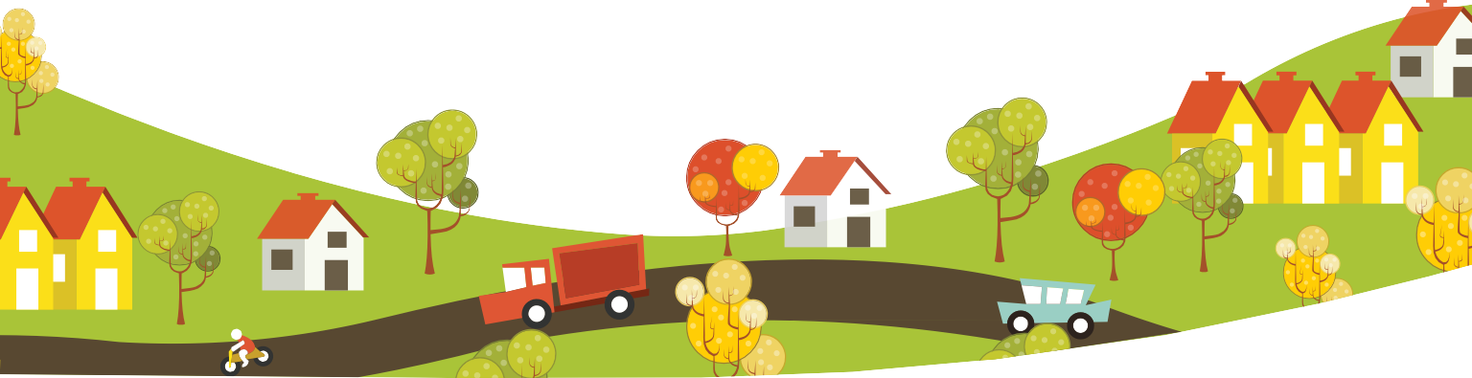
Neighborhoods Small Grants Program
The Community Foundation of Greater Flint Neighborhoods Small Grants Program is seeking to fund projects in the following categories:
Grants Available for 2024
Traditional Mini-Grants Up to $1,000 Next Level & Arts Mini-Grants Up to $5,000 Transformation Grant Up to $25,000
Note: Variations may occur in grant awards
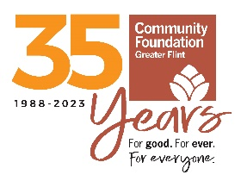

Strengthening Neighborhood Groups/ Organizations
- Increase and expand involvement in neighborhood groups by residents of all ages
- Increase resident involvement in planning and implementing strategies designed to benefit their neighborhood
- Improve the skills necessary to define and resolve pressing neighborhood issues and build leadership within grassroots organizations

Creating Safe Environments
- Activate residents’ ability to act together on activities that improve neighborhood safety
- Stimulate interaction between youths and adults
- Involve residents in neighborhood institutions, such as community schools, crime watches, block clubs, etc.

Improving Neighborhood Conditions
- Improve the appearance of neighborhood environments
- Inspire residents to use their collective economic power to encourage entrepreneurship and economic development in neighborhoods

Creating Opportunities for Neighbors to Connect to Each Other and to Resources & Neighborhood Arts Programs
- Neighborhood celebrations, fairs, block parties
- Talent sharing, time-banking
- Community resource and basic needs fairs
- Network building
- Neighborhood Art, Festival Parades, Exhibits, Showcases
Virtual activities and events encouraged where social distancing is necessary.

Healing Racism
- Racial healing circles
- Neighborhood history projects
- Land Acknowledgment projects
- Community dialogues

Who is eligible to apply?
- Block Clubs/Neighborhood Associations that have a
D.B.A. and Bank Account
- Faith-Based Organizations
- Grassroots Community-Based Organizations
- Nonprofit Organizations

How to Apply: See attached guidelines and application for information. Contact Damon Ross at dross@cfgf.org 810.767.8270. Submit proposals by email to NSGP@cfgf.org or send to Community Foundation at 500 S. Saginaw St., Suite 200, Flint, MI 48502 on or before Friday, March 15, 2024, at 3:00 p.m.

Community Foundation of Greater Flint Neighborhoods Small Grants Program 2024 Grant Guidelines

Funding for the Neighborhoods Small Grants Program is made possible by the Charles Stewart Mott Foundation, Ruth Mott Foundation, and the Community Foundation of Greater Flint.

The Neighborhoods Small Grants Program (NSGP) was created to support established and emerging citizen-based groups or organizations in moderate to low-income neighborhoods in and near the City of Flint to develop projects that address pressing issues within their neighborhoods; build alliances with other community institutions; and develop community-based leadership.

The intended outcomes of NSGP grants are:

  - Community members actively engage in community change efforts
  - Community members view themselves as stakeholders that can partner with institutions to address critical issues
  - Community members have pride in their neighborhoods and motivation to continue their work

Traditional Mini-Grants: Funding up to $1,000 will be awarded for projects that support community building and engagement efforts. Projects can include but are not limited to: neighborhood clean-ups, block parties, crime watch activities, neighborhood newsletters, and the planting of community gardens on vacant lots.

Who is eligible to apply: Block clubs, neighborhood associations, community- based and faith-based organizations that serve neighborhoods in partnership with residents of the neighborhood. A bank account in the group’s name, and a D.B.A. with Genesee County is required if not formally organized as a nonprofit. Formal 501(c)3 status is not required.

Next Level Mini-Grants: Funding up to $5,000 will be awarded to support larger, more comprehensive community projects based on needs assessments conducted by methods such as, neighborhood surveys, focus groups, or community dialogue or listening sessions. The purpose of the Next Level Mini Grant is to provide support for the development of projects that help to engage residents in identifying and addressing community needs in new and creative ways. Grants will be awarded to groups who can successfully demonstrate how this funding would increase their ability to move beyond traditional mini-grant projects such as expanding a simple beautification of a single property or lot to a phased landscaping effort; repurposing vacant and/or abandoned property into vibrant community spaces, i.e. a pocket park, or a community resource center; and/or increasing the size, scale and distribution of a community garden. Next Level Mini-Grants typically leverage other funds and resources to bring about the desired community change.

Who is eligible to apply: 501(c)3 charitable nonprofits and other formally recognized tax-exempt entities such as faith-based institutions, municipalities, schools, and hospitals who are actively partnering with, and informed by residents and neighborhood leaders.

Transformational Grants: At least one grant of up to $25,000 will be awarded for a project that improves the condition of a Flint neighborhood by transforming a vacant and or blighted outdoor public space into an area that is well-maintained; and that creates, enhances and/or significantly expands a community gathering space. Other criteria for the Transformational Grant are as follows:
  - Project must be driven by resident input
  - Project must be part of a formal planning process such as, neighborhood, parks or land use plans and aligned the ImagineFlint Masterplan
  - Project involves partnerships between resident-led groups and non-profit, charitable organizations and/or institutions
  - Projects must have or leverage other sources of financial support
  - Applicants must be able to demonstrate a track record of capacity to plan and carry out effective community place-making projects.

Who is eligible to apply: 501(c)3 charitable nonprofits and other formally recognized tax-exempt entities such as faith-based institutions, municipalities, schools, and hospitals who are actively partnering with residents to improve community.

Block clubs, neighborhood associations and other community-based groups that are not tax exempt are encouraged to partner with eligible nonprofits for Next Level and Transformational Grants.

Priority consideration will be given to applications at each level with projects that involve residents in planning development and implementation.

Restrictions: Individuals and for-profit businesses are not eligible for grant funding.

How to apply: Complete & submit following
  - Traditional Mini-Grants – Completed Application and Attachments A&B
  - Next – Level and Transformational Grants – Completed Application and Attachments A, B, & C
By email to NSGP@cfgf.org or
By mail or in-person delivery by 3:00 p.m. March 15, 2024:

Community Foundation of Greater Flint 500 S. Saginaw Street, Suite 200
Flint, MI 48502 C/O NSGP

For technical assistance or help with questions about the application contact:
Damon Ross, Program Officer – (810) 382-0068 or dross@cfgf.org.

